**Neural Network Structure**

The neural network consists of three layers. The predictors form the bottom layer, the predicted output form the top layer and, the ones of the middle between them form the intermediate layers called the hidden neurons.

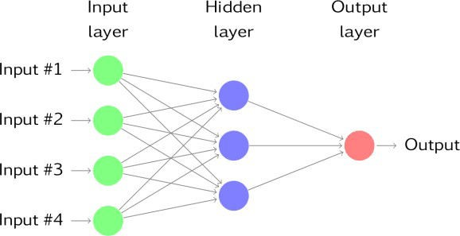

As we can see from the above graph, each layer of intermediate nodes takes the input from the previous layer. Each node and corresponding weight coefficients are combined in linear regression. Because of the hidden neurons(j), the output is recalculated by a nonlinear function. This is called the **multilayer feed- forward network**.



As mentioned before, the output is recalculated by the sigmoid function, which is nonlinear.



The modified output is given to the next layer as an input. This process is useful for the network to be robust to outliers. The weights ( ) are randomly chosen and then learn from the observations by minimizing the cost function (e.g. MSE).

In time series regression, lagged values of data are used as input by a neural network, which is called the **neural network autoregression(NNAR)**. We will use feed-forward with one hidden layer, which is denoted NNAR(p, k). **p** indicates lagged values, and **k** denotes the nodes in the hidden layer.

For seasonal time series, it is better to include that the last observation from the same term from the previous year. In this case, it is denoted as  indicates that:

 for the lagged inputs(predictors). for the seasonal terms.

For non-seasonal time series data, the default **p** value is determined by the optimal number of lagged inputs according to the Akaike’s information criterion.



**T** is the number of observations. **SSE**: sum of the squared of errors. **k** is the number of predictors.

If k is not selected at first, it is determined as  . The network repeats 20 times as default and is trained for starting points which are different random weights. All the results are averaged for ultimate output. The process uses lagged values as inputs for a one-step forecast. This forecast along with the lagged values is used to predict a two-step forecast. This process continues until it meets the required forecasts.

We will prefer the non-seasonal approach because the data we will be using is less than the two periodic cycles required for detecting seasonality. We are going to predict daily cases in the UK for the next 30 days. Data is available at https://github.com/mesdi/nnar/blob/main/covid_uk.csv

library(tidyverse) library(forecast) library(purrr) library(lubridate)

#Building the dataframe

df <- read_csv("covid_uk.csv",

col_types = list(col_character(),

col_date(format = "%d/%m/%Y"), col_double()))

#Converting to the time series data

inds <- seq(as.Date("2020-01-31"), as.Date("2021-05-21"), by = "day") df_ts <- df %>%

.$new_cases %>%

ts(start = c(2020, as.numeric(format(inds[1], "%j"))),frequency = 365)

Before modeling the data, we will use bootstrap aggregating to prevent overfitting and improve accuracy. We will make a function to predict, and show the results in a plot, but before doing that, we create a date transform variable to be used for readable dates.

#The function to convert decimal date to the proper format date_transform <- function(x) {format(date_decimal(x), "%b %Y")}

#Forecasting with Simulated Neural Network and plotting the results sim_nn <- function(data, freq, h, n=100){

#For reproducible results set.seed(123)

#Bootstraping the time series

sim <- bld.mbb.bootstrap(data, n)

#Bagged Neural Network future <- sim %>%

map(function(x){simulate(nnetar(x, P=0),nsim=h)}) %>% unlist() %>%

matrix(ncol = h, nrow = n, byrow = TRUE) %>% pmax(0)#preventing the negative values

#The beginning date of the prediction start <- tsp(data)[2]+1/freq

#Forecast object with prediction intervals #at %5 significance level

sim_fc <- structure(list(

mean = ts(colMeans(future), start=start, frequency=freq),

lower = future %>% as.data.frame() %>% map_dbl(quantile, prob = 0.025) %>% ts(start = start,frequency = freq),

upper = future %>% as.data.frame() %>% map_dbl(quantile, prob = 0.975) %>% ts(start = start,frequency = freq),

level=95), class="forecast")

#Making predictions global variable for easy access assign("simfc",simfc,envir = .GlobalEnv)

#Plotting the prediction results with the observations sim_plot <- autoplot(data)+

autolayer(simfc)+

scale_x_continuous(labels = date_transform,breaks = seq(2020,2022,0.2))+ ylab("")+xlab("")+

ggtitle("Daily Cases of United Kingdom")+ theme_light()+

theme(plot.title = element_text(hjust = 0.5))

#Converting time series with decimal date #to the dataframe for proper demonstration

start <- start %>% as.numeric() %>% date_decimal() %>% as.Date() h_date <- seq(start, start+29, by = "day")

simfc_df <- simfc %>% data.frame() rownames(simfc_df)<- h_date

#The output list list(simfc_df,sim_plot)

}

sim_nn(df_ts,365,30)

